
PROJECT REPORT OF CO-OP
Project at Industry (Module-2)

ON

Open Source Issue Recommender

submitted in partial fulfilment of the requirements
for the award of degree of

BACHELOR OF ENGINEERING
In
COMPUTER SCIENCE AND ENGINEERING

Submitted by:  Shubham Sharma (2210992369)  Sidharth (2210992378)  Shubham Mittal (2210992367) | Supervised By:  Dr. Swati  Assistant Professor  CSE

DEPARTMENT OF COMPUTER SCIENCE AND ENGINEERING
CHITKARA UNIVERSITY INSTITUTE OF ENGINEERING AND TECHNOLOGY
CHITKARA UNIVERSITY, PUNJAB, INDIA

CONTENTS

S.No. | Title | Page No.
 | Acknowledgement | iv
 | Abstract | v
1 | Introduction | 1
2 | Technology Background and Architecture Decisions
3 | System Architecture
4 | Core Functionality Implementation
5 | Integration Architecture
6 | Security Implementation
7 | Testing and Quality Assurance
8 | Deployment Architecture
9 | Technical Specifications
10 | Innovation and Intellectual Contribution
11 | Future Scope and Enhancement Roadmap
12 | Legal Framework and Copyright Basis
13 | Conclusion
 | Appendices

DECLARATION

We hereby certify that the work which is being presented in the project report entitled "Open Source Issue Recommender" in partial fulfilment of the requirement for the award of the degree of Bachelor of Engineering (Computer Science and Engineering) submitted in the Department of Computer Science and Engineering at Chitkara University Institute of Engineering and Technology, Chitkara University, Punjab, India, is an authentic record of our own work carried out under the supervision of <Dr. Swati>. The matter presented in this project report has not been submitted in any other university or institute for the award of any degree.

Place: Rajpura  Date: 2nd May 2026 | (Shubham Sharma)  (2210992369)  (Sidharth)  (2210992378)  (Shubham Mittal)  (2210992367)

This is to certify that the above statement made by the candidates is correct to the best of my knowledge and belief.

(Dr. Swati)
Assistant Professor
Department of Computer Science and Engineering
Chitkara University Institute of Engineering and Technology,
Chitkara University, Punjab, India

ACKNOWLEDGEMENT

It is our pleasure to be indebted to the various people who directly or indirectly contributed in the development of this work and who influenced our thinking, behaviour, and acts during the course of study. We express our sincere gratitude to all for providing us an opportunity to undergo the Integrated Project as part of the curriculum.
We are thankful to Dr. Swati for her support, cooperation, and motivation provided to us during the training, and for the constant inspiration, presence, and blessings throughout the project. We also extend our sincere appreciation to her for providing valuable suggestions and precious time in helping us complete this project report.
We thank the Department of Computer Science and Engineering at Chitkara University Institute of Engineering and Technology, Chitkara University, Punjab, India for providing the academic environment, infrastructure, and continued encouragement that made this project possible. We acknowledge the open-source community whose freely available libraries and documentation form the technical foundation of this work.
Lastly, we would like to thank the Almighty and our parents for their moral support, and our friends with whom we shared our day-to-day experience and from whom we received many suggestions that improved the quality of our work.

ABSTRACT

Open-source software is built by people who share their work freely, but the path into a first contribution remains discouraging for students and early-career developers. While GitHub provides the "good first issue" label as an entry signal, in practice these issues are often crowded by many newcomers at once, poorly scoped, or already being actively worked on by someone else. Finding an issue that genuinely matches a contributor's skills and capacity typically requires scanning many repositories by hand, which wastes time and erodes the motivation to participate. This project, the Open Source Issue Recommender, is a working prototype that addresses this gap by curating and ranking GitHub issues for individual contributors based on their declared skill profile.
The system is built on the MERN stack with React and Vite on the frontend, an Express REST API and Node.js services on the backend, and MongoDB as the primary data store. A separate ingestion and signal-computation pipeline collects open issues from the GitHub REST API, filters out pull requests, normalises the payloads, and enriches each issue with repository metadata. A dedicated signal-computation job derives four primary signals for every issue: freshness, comment-based crowd pressure, repository activity, and label intent. The label-intent signal is computed using a locally hosted Ollama large language model that reads issue descriptions and returns a beginner-friendliness estimate, with a deterministic rule-based fallback whenever the model is unavailable. The ranking engine combines these stored signals with a request-time stack-match score against the user's languages and skill levels.
When a contributor submits a skill profile, the backend loads the cached issue, repository, and signal collections, builds in-memory lookup maps, and computes a weighted composite score for each issue. A small randomised diversification factor is added to prevent identical clustering across users with similar profiles. The response includes each recommended issue together with the individual signal values that drove its rank, so the user can see exactly why it was suggested. The frontend renders the ranked list as transparent issue cards with direct GitHub links. The system therefore replaces uninformed manual searching with a curated, explainable shortlist that respects the contributor's actual skills and the live state of the open-source community around each issue. The deliberate split between offline ingestion, signal computation, and request-time ranking, together with a deterministic fallback whenever the language model is unavailable, makes the platform robust, fast, and extensible: additional ingestion adapters and signals can be added without disturbing the existing layers.

1. Introduction

1.1 Problem Background
Contributing to open-source software is widely recommended for students and junior developers, but in practice the on-ramp is far less smooth than the recommendation suggests. GitHub provides the "good first issue" label as a convention to mark approachable work, yet these labelled issues are typically discovered by many newcomers at the same time. The result is overcrowding: a single approachable issue may collect a dozen comments from prospective contributors competing for the same fix, or it may already be in progress without that being clearly stated. Issues that do remain genuinely open are often spread across hundreds of repositories, are inconsistently scoped, or sit in repositories that have been inactive for months. Sifting through this surface is time-consuming and discouraging, and many motivated learners abandon the attempt before submitting a single pull request.

1.2 Objective of the Project
The objective of the Open Source Issue Recommender is to deliver a small, ranked, and explained shortlist of GitHub issues that genuinely match the contributor's declared technology stack, are unlikely to be overcrowded, and live in repositories that are still actively maintained. Each recommendation must be transparent: the contributor should see exactly which signals led to its rank.

1.3 Proposed Solution and System Overview
The proposed solution is a complete end-to-end web application that combines a React-based user interface, an Express REST API, a MongoDB datastore, and a locally hosted Ollama large language model. A separate ingestion pipeline pulls open issues from the GitHub REST API, normalises them, and stores them along with repository metadata. A signal-computation pipeline then enriches every cached issue with four ranking signals: freshness, crowd pressure, repository activity, and label intent. At request time the user submits a skill profile through a form. The backend loads the cached collections, computes a stack-match score against the user's languages, aggregates the precomputed signals into a weighted composite score, and returns a sorted list of issues with explanation metadata. The frontend then renders each result as a card containing the issue title, repository, score breakdown, and a direct GitHub link.

1.4 Key Features and Functionality
The platform provides skill-profile-driven ranking with transparent score breakdowns, freshness-aware issue prioritisation, crowd-pressure detection from comment counts, repository-activity penalisation for stale projects, AI-assisted label-intent scoring through a local Ollama model, deterministic fallback to rule-based scoring whenever the model is unavailable, and a clear UI showing exactly which factors drove each recommendation's position in the list.

1.5 Technology and Method Used
The system is implemented using the MERN stack: React with Vite for the frontend SPA, Node.js with Express for the REST API, and MongoDB accessed through the Mongoose ODM for persistent storage. Issue analysis uses a locally hosted Ollama runtime, which serves an open-weight large language model for beginner-friendliness scoring. Tailwind CSS provides the styling layer, and react-hook-form manages dynamic profile input on the frontend.

1.6 Expected Outcome and Benefits
Contributors using the system receive a curated shortlist of approachable issues rather than dozens of browser tabs from manual repository scanning. Each recommendation is paired with its signal values, so the user understands the trade-offs and can make an informed choice. The path from interest to a first contribution is shortened, the matching to the user's actual stack is more reliable, and the overall experience of starting in open source becomes less intimidating.

1.7 Original Contribution Statement
This project introduces a recommender system built on the unique principle of "a transparent, signal-aware ranking layer for low-crowd, beginner-appropriate open-source issues", differentiating it from generic GitHub search and from existing curated lists by combining stack matching, time-decay signals, crowd detection, repository health, and AI-assisted label-intent analysis into a single explainable shortlist.

2. Technology Background and Architecture Decisions
This chapter documents the technical rationale behind every major architectural and technology selection made during the design and development of the Open Source Issue Recommender. These decisions constitute original intellectual work and reflect the authors' judgement applied to competing technical trade-offs.

2.1 Choice of the MERN Stack
The MERN stack was selected for the platform after evaluating it against alternative full-stack combinations. The decisive factors were the consistency of using JavaScript across both client and server, the maturity of the npm ecosystem for HTTP, validation, and integration libraries, and the ease with which JSON-shaped data flows from the GitHub API through the application's internal services to the browser without intermediate serialisation overhead.
Stack Choice | Rationale
React + Vite (frontend) | React provides component-based UI composition that maps cleanly to issue cards, profile inputs, and results lists. Vite offers near-instant hot module replacement during development and a small, fast production build, which keeps iteration cycles tight.
Node.js + Express (backend) | Express's middleware pattern keeps the API surface minimal and explicit. Node.js's event-loop model is appropriate for a workload that is dominated by I/O against MongoDB, the GitHub API, and Ollama, with low CPU computation per request.
MongoDB + Mongoose | GitHub issues and repository metadata have variable, partly nested shapes that fit naturally into document storage. Mongoose adds a typed schema layer over those documents and gives us validation and projection helpers without requiring the rigidity of a relational model.

2.2 Cached-Signal Architecture
A naive implementation would call the GitHub API and the language model on every user request. We rejected this design for two reasons: it would consume the GitHub API rate limit very quickly, and it would push request latency into the multiple-seconds range, which is a poor experience. Instead, the system runs a separate ingestion job that fetches issues, filters out pull requests, and stores normalised issue and repository documents. A second signal-computation job then derives the freshness, crowd, repository-activity, and label-intent signals once per issue and stores them in a dedicated signals collection.
This separation means request handling becomes a fast database read, an in-memory lookup-map join across the three collections, and a numerical aggregation. The user-facing latency is dominated by the database read rather than by external network calls or model inference.

2.3 Why Ollama for Local LLM Inference
Issue clarity and beginner-friendliness are properties that resist purely rule-based estimation. An issue described in three terse sentences and one in three rambling paragraphs may carry the same difficulty in practice. Heuristic shortcuts based on body length, label presence, or code-block count are individually weak signals. We therefore introduced an AI-assisted label-intent score that asks a language model to evaluate the issue text directly.
Decision | Rationale
Local Ollama over a hosted API | Ollama runs locally and processes issue text on the same host as the backend. No issue data leaves the deployment boundary, which is preferable for a student project that does not need to send third-party content to a paid hosted service. There is also no per-request cost, which makes iterative experimentation on weights and prompts affordable.
Open-weight model selection | Ollama serves multiple open-weight model families. The system is model-agnostic at the integration boundary: the llmAnalyzer module sends a prompt and parses a structured response. This means the model can be upgraded or swapped without changing the rest of the codebase.
Deterministic fallback | When Ollama is unreachable, the analyzer returns a deterministic score derived from explicit beginner labels and simple heuristics. The system therefore continues to produce useful recommendations even with the LLM offline, which is essential for a robust student deliverable.

2.4 Hybrid Scoring with Transparency
Pure AI-driven ranking is a black box: the user gets a list and no explanation. Pure rule-based ranking is brittle: well-described issues that lack the right labels are penalised even when they are genuinely beginner-friendly. The platform deliberately combines both, treating the AI score as one signal among several rather than as the entire answer. Because each signal is stored separately and surfaced in the response, the user can read each issue's score breakdown and judge whether the ranking matches their personal preference.

2.5 In-Memory Lookup Maps Over Database Joins
MongoDB does support cross-collection joins through the aggregation pipeline, but for the platform's ranking workload we chose a simpler approach. The ranking function loads the issue, repository, and signal collections in three separate queries, then constructs JavaScript Map objects keyed by the relevant identifiers. The subsequent score computation iterates over issues and looks up the associated repository and signal records in constant time.
This pattern is intentional. It keeps the ranking logic readable, it avoids accidental coupling to the aggregation framework, and it makes the function easy to unit test by passing in plain arrays. At the project's current data volumes the loaded data fits comfortably in memory, so the trade-off favours simplicity over query-time optimisation.

3. System Architecture

3.1 High-Level Architecture
The Open Source Issue Recommender implements a layered architecture with four logical tiers: the client tier (the user's browser), the presentation tier (the React SPA), the application tier (the Express REST API and its supporting services), and the data tier (MongoDB and the Ollama LLM runtime). An offline ingestion pipeline runs on a separate cadence and populates the data tier.
The four tiers are decoupled to permit independent deployment and scaling. The frontend is a static SPA that can be served from any static host. The backend is a stateless Node.js process that can be replicated horizontally. MongoDB is accessed exclusively through Mongoose models, and Ollama is consumed only through the llmAnalyzer module, which abstracts both the prompt structure and the fallback path.
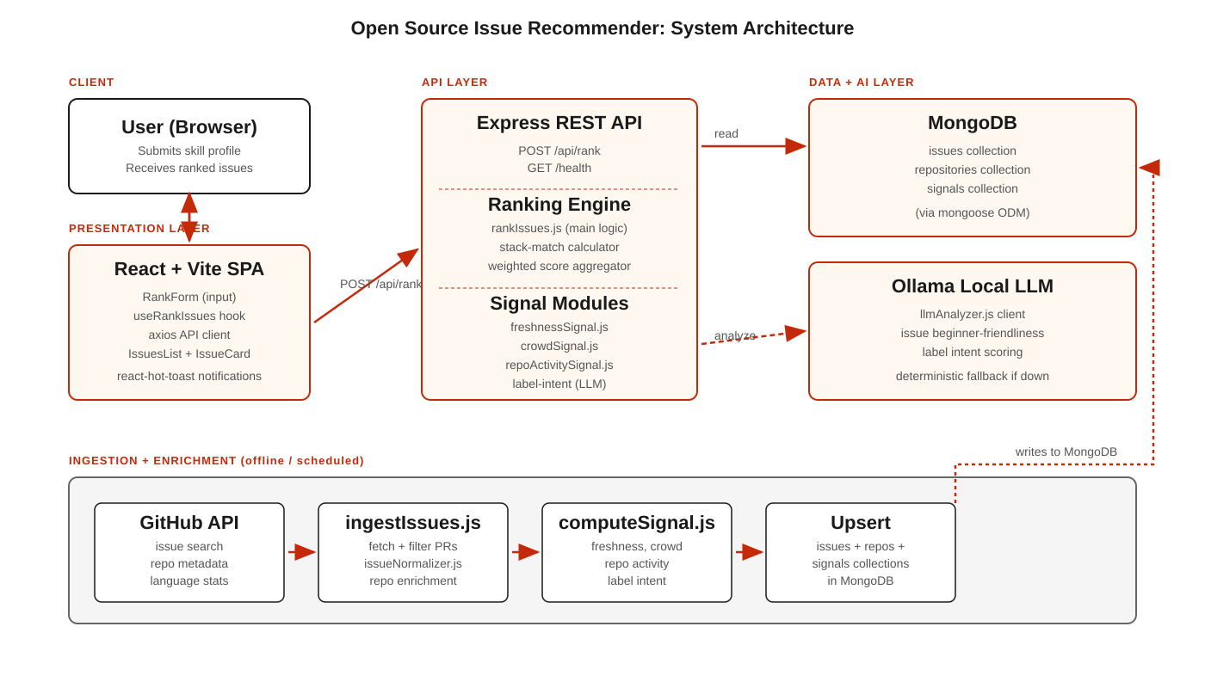
Figure 3.1: Open Source Issue Recommender system architecture, with offline ingestion populating MongoDB and the request-time API serving recommendations from cached signals.

3.2 Component Interaction
The following sequence describes the complete lifecycle of a typical recommendation request: the user submits a skill profile through the React form. The frontend's useRankIssues hook posts the payload to the Express API at /api/rank. The user.controller validates the payload, normalises a single-language input (if that mode was used) into a profile array, and calls the rankIssue function. The ranking function loads the cached issue, repository, and signal collections, builds lookup maps, computes a composite score per issue, sorts the results, and returns them. The frontend renders each result as an IssueCard with the score breakdown and a direct GitHub link.
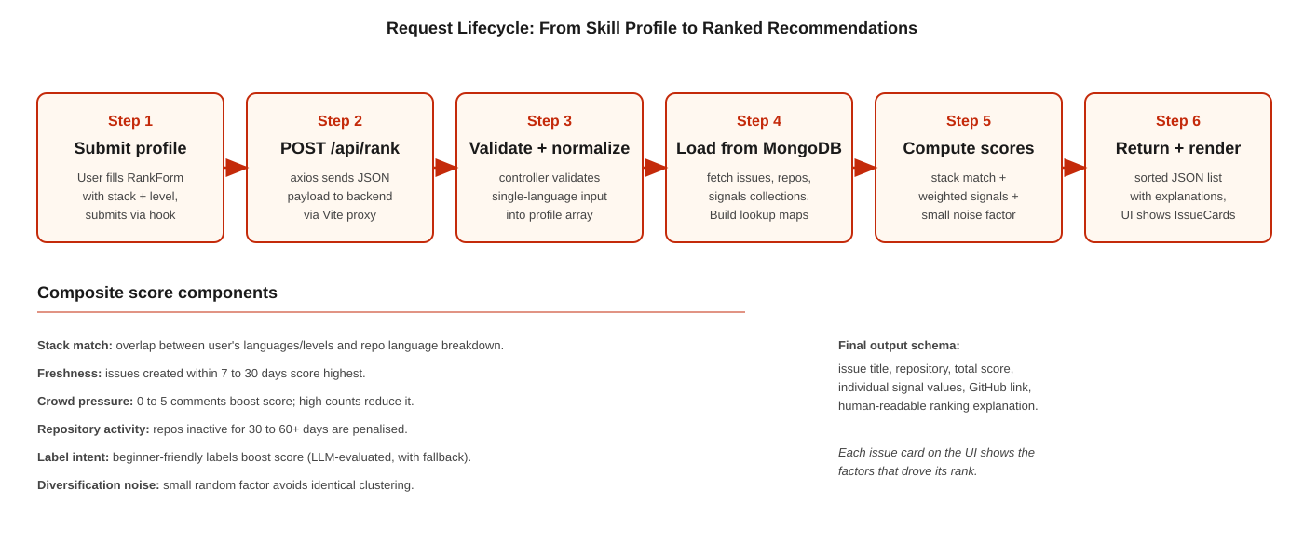
Figure 3.2: Request lifecycle, from user-submitted skill profile to ranked issue cards rendered on screen.

3.3 Database Schema Design
The MongoDB schema is intentionally compact: three collections cover the entire dataset that the ranking engine reads. Each collection has a clearly bounded responsibility, and references between collections are made through stable identifiers rather than embedded copies of upstream documents.

3.3.1 Core Collections
Collection | Purpose and Key Fields
issues | Normalised representation of a GitHub issue. Fields include the GitHub issue ID, title, body, labels, comment count, creation timestamp, last-update timestamp, repository reference, and the issue's HTML URL on GitHub. Pull requests are filtered out at ingestion time.
repositories | Per-repository metadata used by the ranking engine. Fields include the repository's full name, primary language breakdown, last-pushed timestamp, recent commit activity counts, and any additional repo details collected during enrichment.
signals | Precomputed ranking signals per issue. Fields include freshness score, crowd score, repository-activity score, and label-intent score. The signal record references the issue by identifier so the ranking engine can look up the corresponding signals in constant time.

3.3.2 Indexing Strategy
Indexes are added on the fields that participate in the ranking engine's lookup-map construction: issue identifier on the signals collection, repository identifier on the issues collection, and primary language fields on the repositories collection. These indexes make the bulk-load step in rankIssues fast even as the cached dataset grows.

3.4 API Architecture
The REST API exposes a small, focused set of endpoints. Authentication is not required for the ranking endpoint because the platform does not store or correlate user data across requests; the request payload is the entire input. Future versions that add user accounts can introduce a token-based authentication middleware at the route layer without disturbing the ranking pipeline.

3.4.1 Route Module Organisation
Route | Responsibility
POST /api/rank | Accepts a JSON payload containing either a multi-skill profile array or a single language plus experience level. Validates the payload, normalises it, calls the ranking engine, and returns a sorted JSON array of recommended issues, each with its signal breakdown and explanation fields.
GET /health | Lightweight liveness probe. Returns a small JSON document with status and timestamp. Used by the frontend to confirm backend availability before submitting a ranking request, and by deployment platforms for health checks.

3.5 Request and Response Shapes
The request payload accepts two interchangeable shapes for ergonomic reasons. The simpler shape lets a casual user supply only a single language and a level. The richer shape supports a list of languages, each with its own level. The controller normalises the simpler shape into the richer one before invoking the ranking engine, so downstream code only has to handle the unified format.
// Simple input
{ "language": "javascript", "level": "beginner" }

// Rich input
{
"profile": [
{ "language": "javascript", "level": "intermediate" },
{ "language": "python", "level": "beginner" }
]
}

// Response shape (per issue)
{
"title": "Improve error message in CLI",
"repository": "example/repo",
"url": "https://github.com/example/repo/issues/123",
"score": 0.78,
"signals": {
"freshness": 0.92,
"crowd": 0.85,
"repoActivity": 0.71,
"labelIntent": 0.80,
"stackMatch": 0.65
},
"explanation": "Recent issue, low comment activity, repo active in last week."
}

4. Core Functionality Implementation
This chapter describes the implementation of the platform's core data-flow stages, from issue ingestion through signal computation to request-time ranking. Each stage is implemented as a self-contained module so that the responsibilities are clear and individual stages can be modified or replaced independently.

4.1 Ingestion Pipeline
The ingestion pipeline is implemented in src/ingestion. Its entry point, ingestIssues.js, orchestrates the complete sequence: it calls githubClient.js to fetch open issues across the configured repositories, filters out pull requests (which the GitHub Issues endpoint also returns), passes each remaining payload through issueNormalizer.js to produce a stable shape, and upserts the resulting documents into the issues and repositories collections.

4.1.1 GitHub Client
The GitHub client wraps the relevant subset of the GitHub REST API behind small helper functions: fetch issues for a repository, fetch repository details, and fetch the language breakdown. The client uses axios under the hood and respects the GitHub-supplied rate-limit headers, pausing when the remaining quota approaches zero. Authentication uses a personal access token loaded from the environment, which lifts the request quota from 60 requests per hour to 5,000.

4.1.2 Issue Normalisation
Raw GitHub issue payloads contain a substantial amount of metadata, much of which is irrelevant to ranking. issueNormalizer.js extracts the fields that the ranking engine depends on: issue identifier, title, body text, labels, comment count, created-at and updated-at timestamps, repository reference, and HTML URL. Pull requests are detected by the presence of the pull_request field on the payload and discarded at this stage.

4.1.3 Repository Enrichment
Repository documents are enriched with information that the ranking engine uses for stack matching and activity scoring. The language breakdown is fetched from the GitHub languages endpoint and stored as a map of language to byte count. The most recent push timestamp and recent commit-activity counts are stored alongside it. These enrichments are upserted into the repositories collection so that subsequent ingestion runs update the record in place rather than duplicating it.

4.2 Signal Computation
Signal computation is implemented in src/signals and is invoked through computeSignal.js, which is designed to run as a separate scheduled job rather than synchronously inside a user request. The module loads cached issues and repositories, derives four signals per issue, and writes them into the signals collection.

4.2.1 Freshness Signal
Implemented in freshnessSignal.js. The freshness score is highest for issues created within the last seven days and decays smoothly across the next several weeks. Issues older than around sixty days receive a heavily reduced score. The decay is intentionally smooth rather than stepwise so that the ranking does not flip sharply at arbitrary day boundaries.

4.2.2 Crowd Signal
Implemented in crowdSignal.js. The crowd score reflects the comment-driven competition for an issue. Issues with zero to about five comments receive a positive score because the absence of activity suggests no one has yet claimed the work. As the comment count grows the score is reduced, since a high comment count typically indicates either active discussion or a queue of contributors who have already expressed interest. The score is bounded so that pathological comment counts do not produce extreme negative values.

4.2.3 Repository Activity Signal
Implemented in repoActivitySignal.js. Repositories that have not been pushed to in the last thirty to sixty days are penalised, since maintainers who do not respond risk leaving a contributor's pull request unreviewed indefinitely. Repositories with recent commit activity are rewarded. The signal uses the last-pushed timestamp and the recent commit-activity counts collected during enrichment.

4.2.4 Label-Intent Signal (LLM-Assisted)
Implemented through utils/llmAnalyzer.js, called from computeSignal.js. The label-intent signal captures whether an issue's labels and description are genuinely consistent with beginner work. An issue may be tagged 'good first issue' but actually require deep familiarity with the codebase. Conversely, an issue may be unlabelled but read as straightforward documentation work. To capture this nuance the analyzer constructs a prompt that includes the issue title, body, and labels, and queries the local Ollama model for a structured assessment. The analyzer parses the response and produces a numeric label-intent score.
If the Ollama call fails for any reason, the analyzer returns a deterministic score based on the presence of explicit beginner labels and simple textual heuristics. This guarantees that signal computation always completes, even when the LLM is offline, which is critical because the rest of the ranking pipeline depends on the signals collection being fully populated.

4.3 The Ranking Engine
The ranking engine is implemented in src/scoring/rankIssues.js. It is the central piece of the request-time pipeline and is the place where cached signals are combined with the user's profile into a final ordered list.

4.3.1 Stack Match Computation
The stack-match score is computed at request time, not at ingestion time, because it depends on the user's profile. For each issue, the engine looks up its repository, reads the repository's language breakdown, and compares it against the user's declared languages. Each language overlap contributes weighted by the user's level for that language: a self-declared 'intermediate' user gains more from a language overlap than a 'beginner' user, since intermediate users are more likely to be helped by larger repositories where their language is dominant. Issues whose repository has no overlap with any of the user's languages still receive a small non-zero score if there is no other repository on offer, but they sort below stack-relevant issues.

4.3.2 Composite Score Aggregation
The final composite score is a weighted sum of the four cached signals plus the request-time stack-match. The weights are tuned constants in the ranking module rather than learned values; a small randomised noise factor is added to break ties and to diversify results across users with very similar profiles. After scoring, the issues are sorted in descending order and the top results are returned.

4.3.3 Explanation Metadata
Every returned issue object carries the individual signal values that contributed to its score, plus a short human-readable explanation string assembled from the dominant signals. This metadata is the basis for the transparency that the platform claims as a core feature: the user can read, for each issue, why it appears at its position in the list. For example, a card might display "Recent issue, low crowd, active repository," letting the user judge at a glance whether the recommendation is appropriate for them.

4.4 Frontend Implementation
The frontend is implemented as a single-page React application built with Vite. It is intentionally small: a single page hosts the input form and the results, with auxiliary components for individual issue cards and toast notifications.
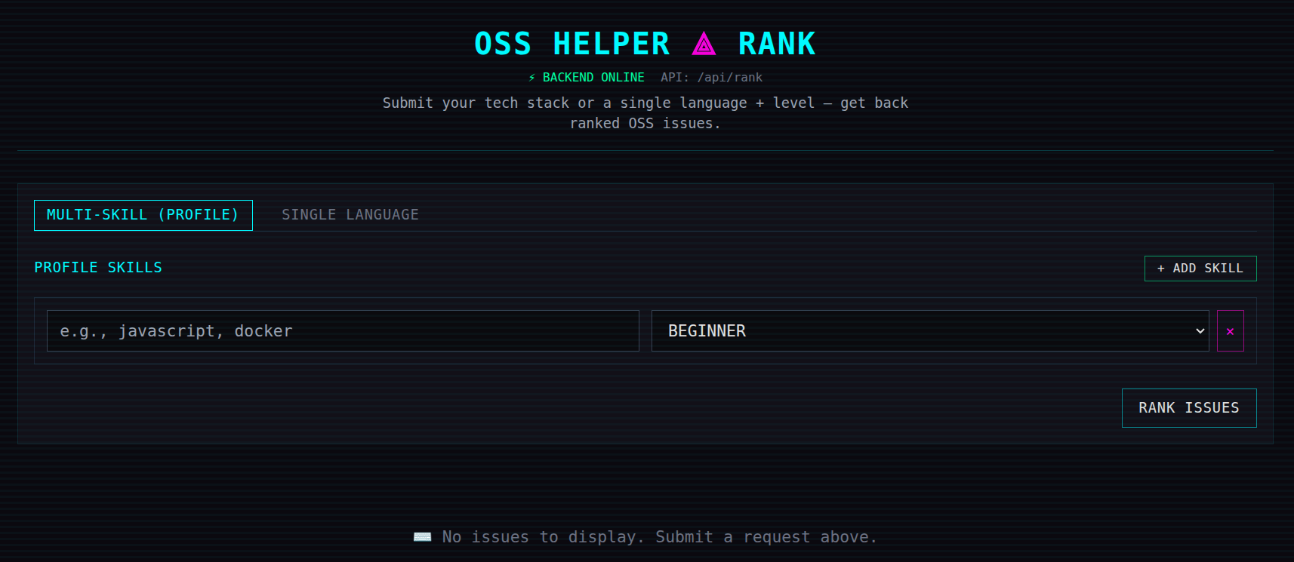
Figure 4.1: Application home page

4.4.1 Input Form
RankForm is the primary input component. It accepts either a single-language entry or a multi-skill profile composed of language and level pairs. Form state is managed by react-hook-form, which handles dynamic profile lists cleanly through its useFieldArray helper. Client-side validation ensures that the language field is non-empty and that the level is one of the allowed values before submission.

4.4.2 useRankIssues Hook
The useRankIssues custom hook encapsulates the API call lifecycle. It exposes a rank function that the form submits to, plus state values for loading, error, and the returned data. This pattern isolates the network-call logic from the UI components and makes it easy to swap the underlying transport without touching the components themselves.

4.4.3 Issue Card Rendering
Once the API call resolves, the IssuesList component renders each returned object as an IssueCard. Each card shows the issue title, the repository name, the composite score, the individual signal values, the human-readable explanation, and a direct hyperlink to the issue on GitHub. Errors and transient states are surfaced through react-hot-toast notifications so that the main results area stays uncluttered.
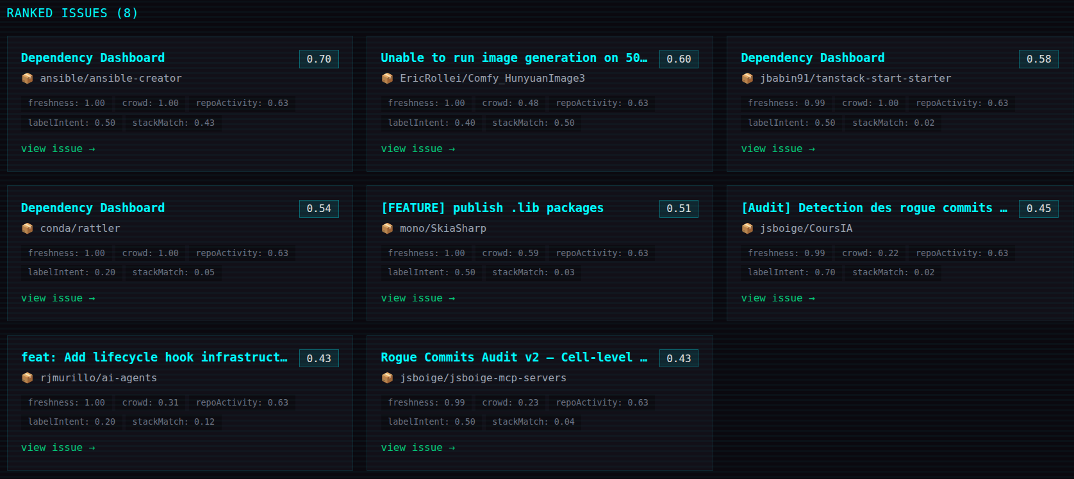
Figure 4.2: Ranked issue results

5. Integration Architecture
The platform integrates with two external systems: the GitHub REST API for issue and repository data, and the locally hosted Ollama runtime for language-model inference. Both integrations are isolated behind small wrapper modules so that the rest of the codebase does not depend on the specifics of either integration's protocol or response shapes.

5.1 GitHub REST API Integration
GitHub provides a comprehensive REST API for accessing issues, repositories, languages, and activity statistics. The platform uses three endpoints. The issues endpoint returns recently updated open issues; the repositories endpoint returns descriptive metadata; and the languages endpoint returns the per-language byte counts that drive the stack-match calculation.

5.1.1 Authentication and Rate Limits
Concern | Handling
Rate limits | Unauthenticated GitHub API access is capped at sixty requests per hour. With a personal access token the limit rises to five thousand requests per hour, which is sufficient for the project's ingestion volume. The client reads the rate-limit headers on each response and pauses when the remaining quota is low.
Pull-request filtering | The issues endpoint also returns pull requests, distinguished only by the presence of the pull_request key. The normaliser drops these records before they reach the issues collection.
Pagination | The client follows the Link header's next pointer until the result set is exhausted or a configured page cap is reached.

5.2 Ollama LLM Integration
Ollama is integrated through utils/llmAnalyzer.js. The analyzer presents a single function to the rest of the codebase: given an issue's title, body, and labels, return a numeric beginner-friendliness score. Internally, the analyzer constructs a prompt instructing the model to return a structured response and sends the prompt to the local Ollama HTTP endpoint.

5.2.1 Prompt Strategy
Because the platform asks the model for a numeric assessment rather than free-form text, the prompt is instructed to return a small JSON object with a fixed schema. Strict response parsing is performed on the result; if the model returns malformed output, the analyzer falls through to the deterministic fallback rather than failing the entire signal-computation run.

5.2.2 Failure Modes and Fallback
Failure | Fallback Behaviour
Ollama service unreachable | Network error caught in llmAnalyzer. Deterministic score returned based on label presence and simple text heuristics. Signal-computation run continues.
Model returns unparseable output | JSON parse error caught. Same deterministic fallback path.
Model returns out-of-range value | Value clamped to [0,1]. No exception raised.

5.3 Frontend to Backend Communication
The frontend communicates with the backend exclusively through axios. During development, Vite's configuration proxies requests beginning with /api to the backend's local port, which avoids any CORS configuration or absolute URLs in the frontend code. In production, the frontend is built as a static bundle and served alongside the backend so that /api requests resolve naturally.

6. Security Implementation
Security considerations for the Open Source Issue Recommender are scoped to the platform's actual threat model. The application does not store user accounts, does not persist personally identifiable information, and does not handle financial transactions. Its security posture therefore focuses on input validation, safe handling of secrets, and isolation of external integrations.

6.1 Input Validation
All requests to /api/rank are validated by the user controller before any business logic executes. The validation enforces the request shape (either the simple single-language form or the rich profile array), restricts the level field to a fixed set of values, rejects empty language strings, and caps the profile array at a reasonable upper bound. Invalid requests return a 400 status with a clear error message rather than being silently discarded.

6.2 Secrets Management
Secret | Handling
GitHub personal access token | Loaded from the GITHUB_TOKEN environment variable through dotenv. Never committed to the repository. Used only by the ingestion pipeline; the request-time API does not need GitHub credentials.
MongoDB connection string | Loaded from the MONGODB_URI environment variable. In development this points to a local instance; in production it is provided by the deployment platform.
Ollama endpoint URL | Loaded from environment configuration. Defaults to localhost when running on the same host as the backend. Not a secret in the cryptographic sense, but kept in environment configuration to avoid hard-coded URLs.

6.3 Local LLM Boundary
Because the language model runs locally through Ollama, issue text never leaves the deployment boundary. There is no third-party LLM provider receiving content that the platform processes. This is a deliberate design choice for both privacy and cost reasons, and it means the platform does not need to maintain a data-processing agreement with an external AI vendor.

6.4 Read-Only GitHub Access
The platform's GitHub integration uses read-only API endpoints. It does not create, comment on, modify, or close any issue or pull request. Because the personal access token is configured for read-only scopes, even an accidental misuse cannot mutate any external repository state.

6.5 CORS and Transport
In development, Vite's proxy ensures that all frontend requests originate from the same origin as the backend. In production, when the frontend bundle is served by the backend or by a reverse proxy in front of it, all requests share the production origin. CORS is therefore configured restrictively, permitting only the production frontend's origin to call the API. HTTPS is required for production deployment so that requests, including any future user-supplied data, traverse encrypted transport.

7. Testing and Quality Assurance
Quality assurance for the platform combines static analysis on the codebase, manual functional testing of the ranking pipeline, and edge-case verification of the fallback paths. The testing approach is appropriate for the project's scope and prepares the codebase for the addition of automated unit tests as the system matures.

7.1 Static Analysis and Linting
JavaScript on both the frontend and the backend is checked with ESLint. The configuration enforces consistent quote style, semicolon usage, unused-variable detection, and basic prefer-const and no-var rules. Linting is part of the development workflow rather than an afterthought, which keeps the codebase visually consistent and catches common errors before they reach the running application.

7.2 Manual Functional Testing
The ranking pipeline is verified by a sequence of manual test scenarios that exercise the system end to end. Each scenario submits a known profile, observes the returned ranking, and confirms that the explanation metadata aligns with the expected dominant signals.
Scenario | Expected Behaviour
Beginner JavaScript profile | Returns issues from JavaScript-heavy repositories with low comment counts and recent timestamps. Stack-match dominates the explanation, freshness is positive.
Intermediate Python profile | Returns issues from active Python repositories. Stack-match contributes more strongly than for the beginner case. Issues from inactive Python repositories rank below those from active ones.
Mixed profile (JavaScript + Python) | Returns a mixed list. Issues whose repository has language overlap with either of the user's languages are eligible. The composite score reflects which language dominates each repository.
Empty profile (edge case) | Treated as an under-specified request: the controller returns a structured 400 with a clear error, rather than running an unbounded ranking against the entire dataset.

7.3 Fallback Path Verification
The deterministic fallback in llmAnalyzer is verified by stopping the Ollama service and running computeSignal.js against a small fixture set. The expected behaviour is that signal computation completes successfully, label-intent scores fall back to the heuristic path, and the resulting ranking remains coherent. This test is repeated whenever the fallback heuristic is modified to ensure that no regression has been introduced.

7.4 Performance Observations
Recommendation requests at typical cached-data volumes complete in well under a second on a developer machine, dominated by the three MongoDB reads rather than by the in-memory score computation. Ingestion-pipeline runs are bounded by GitHub API rate limits and by Ollama inference time on issue text. Both stages are intentionally placed off the request path so that user-facing latency is unaffected by their duration.

8. Deployment Architecture
The Open Source Issue Recommender is designed for straightforward deployment on commodity infrastructure. The application has three runtime components: the static frontend bundle, the Node.js backend process, and the MongoDB database. Ollama runs as a separate process on the same host as the backend, or on a host the backend can reach over the network.

8.1 Local Development Setup
Local development requires Node.js, a running MongoDB instance (either local or hosted), and a running Ollama service. Vite serves the frontend on its development port and proxies API requests to the backend. Hot module replacement on the frontend and nodemon-style watching on the backend give a fast inner loop. A README.md in the repository root documents the steps and the required environment variables.
Component | Local Configuration
Frontend (Vite) | Runs on port 5173 by default. vite.config.js declares a proxy that maps /api requests to the backend's local port.
Backend (Express) | Runs on port 5000 by default. Connects to MongoDB at the URI specified by MONGODB_URI. Uses the OLLAMA_URL environment variable to locate the Ollama instance.
MongoDB | Local instance via the MongoDB Community Edition, or a hosted instance via MongoDB Atlas. Either is accessed through the same Mongoose connection logic.
Ollama | Runs locally on its default port. The model is pulled once with a single ollama pull command and cached on disk for subsequent runs.

8.2 Environment Configuration
Variable | Purpose
MONGODB_URI | Full MongoDB connection string. Required. In development points to a local instance; in production supplied by the deployment platform's database service.
GITHUB_TOKEN | Personal access token for GitHub API authentication. Lifts the rate limit from 60 to 5,000 requests per hour. Required for the ingestion pipeline.
OLLAMA_URL | URL of the Ollama HTTP endpoint. Defaults to a localhost address when omitted. Used by the llmAnalyzer module.
PORT | Backend HTTP port. Defaults to 5000.
NODE_ENV | Selects between development and production modes. Affects logging verbosity and CORS configuration.

8.3 Production Deployment Options
Several deployment topologies are compatible with the platform's architecture. The frontend bundle can be served by any static host or directly by the backend. The backend can run on any platform that supports Node.js processes. MongoDB is most easily provisioned through MongoDB Atlas, which removes the operational burden of running the database directly. Ollama can run on the same host as the backend on a small VM, or on a dedicated host with more memory if larger models are required.
Topology | Suitability
All-in-one VM | Backend, MongoDB, and Ollama on a single virtual machine. The simplest setup. Suitable for demonstration and small-scale use. Resource contention between the LLM and the database is the main concern at scale.
Backend on PaaS, MongoDB Atlas, separate Ollama host | Backend deployed to a platform-as-a-service provider such as Render or Railway. MongoDB on Atlas. Ollama on a dedicated VM. Cleanest separation of concerns and the easiest to scale independently.
Static frontend on CDN, backend on PaaS | Frontend bundle served from a CDN such as Vercel or Netlify with the backend on a separate PaaS provider. Reduces frontend load times globally. Backend continues to handle API requests.

8.4 Scaling Considerations
Because the backend is stateless, horizontal scaling is achieved by running multiple backend replicas behind a load balancer. Each replica connects to the same MongoDB cluster and Ollama endpoint. The ingestion and signal-computation jobs run on a single replica or on a dedicated worker container so that the work is not duplicated. MongoDB scales vertically up to the largest instance offered, and read replicas can be added if request load grows. Ollama is the most resource-intensive component, so dedicating it to a host with sufficient memory is the primary scaling lever once the request volume becomes non-trivial.
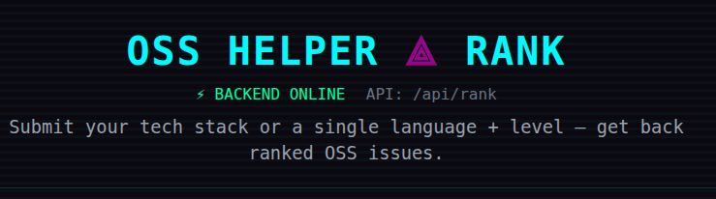
Figure 8.1: Application running in deployed environment

9. Technical Specifications

9.1 Codebase Composition
The codebase is organised into a clean separation between frontend and backend, with each side split further by responsibility. The structure is intentional: routes, controllers, scoring, signals, ingestion, models, and utilities each live in their own directory so that any new developer joining the project can locate functionality quickly.
Area | Description
Backend route module | Single REST router exposing /api/rank and /health, mounted under /api in the Express app.
Controller module | user.controller handles the rank request: validation, profile normalisation, ranking invocation.
Scoring module | rankIssues.js as the production ranker; scoringLogic.js as exploratory scratch code that informed the design but is not on the active path.
Signal modules | Four files: computeSignal.js (orchestration), freshnessSignal.js, crowdSignal.js, repoActivitySignal.js. The label-intent signal is computed via the LLM analyzer.
Models | Mongoose schemas for issue, repository, and signal collections.
Ingestion modules | githubClient.js (HTTP wrapper), issueNormalizer.js (normalisation), ingestIssues.js (orchestration).
Utilities | llmAnalyzer.js for Ollama integration.
Frontend pages | HomePage as the single user-facing page hosting the input form and results.
Frontend hooks | useRankIssues encapsulates API call lifecycle.
Frontend services | axios client and request helpers.
Frontend components | RankForm and supporting input components, IssuesList, IssueCard.
Styling | Tailwind CSS with a custom theme; assets/styles/index.css for base overrides.

9.2 Project Structure
The repository is organised as a single workspace containing a frontend directory and a backend directory side by side. This layout keeps the two halves of the application discoverable while still allowing them to be deployed independently. The complete tree is reproduced below.
open-source-issue-recommender/
├── backend/
│ ├── src/
│ │ ├── index.js Express app bootstrap, /api mount, MongoDB connect
│ │ ├── API/
│ │ │ ├── routes.js Exposes POST /api/rank
│ │ │ └── user.controller.js Validates request, calls ranking
│ │ ├── scoring/
│ │ │ ├── rankIssues.js Main ranking logic
│ │ │ └── scoringLogic.js Exploratory scratch ideas
│ │ ├── signals/
│ │ │ ├── computeSignal.js Orchestrates signal generation
│ │ │ ├── crowdSignal.js
│ │ │ ├── freshnessSignal.js
│ │ │ └── repoActivitySignal.js
│ │ ├── models/
│ │ │ ├── issue.js
│ │ │ ├── repository.js
│ │ │ └── signal.js
│ │ ├── ingestion/
│ │ │ ├── githubClient.js GitHub REST API helpers
│ │ │ ├── issueNormalizer.js Normalises raw payloads
│ │ │ └── ingestIssues.js Orchestrates ingestion + repo enrichment
│ │ └── utils/
│ │ └── llmAnalyzer.js Ollama client for issue analysis
│ ├── package.json
│ └── .env.example
├── frontend/
│ ├── src/
│ │ ├── main.jsx App entrypoint
│ │ ├── App.jsx Global wrapper, toast provider
│ │ ├── pages/
│ │ │ └── HomePage.jsx Health check, form, results
│ │ ├── hooks/
│ │ │ └── useRankIssues.js API call state management
│ │ ├── services/
│ │ │ └── api.js axios client and helpers
│ │ ├── components/
│ │ │ ├── RankForm.jsx
│ │ │ ├── IssuesList.jsx
│ │ │ └── IssueCard.jsx
│ │ └── assets/styles/
│ │ └── index.css
│ ├── tailwind.config.js
│ ├── vite.config.js
│ └── package.json
└── README.md

9.3 Dependency Reference
The platform's runtime dependencies are listed below by area, with the role each package plays.

9.3.1 Backend Dependencies
Package | Role
express | Core web framework. HTTP server, routing, middleware chain, request and response handling.
mongoose | MongoDB ODM. Defines schemas for issue, repository, and signal collections; manages the connection.
dotenv | Loads environment variables from a .env file in development.
axios | HTTP client used by the ingestion pipeline to call the GitHub REST API.
ollama | Client for the local Ollama service used by llmAnalyzer for beginner-friendliness scoring.

9.3.2 Frontend Dependencies
Package | Role
react / react-dom | UI framework.
vite | Development server and production build tool.
tailwindcss | Utility-first CSS framework. Custom theme defined in tailwind.config.js.
react-hook-form | Form state and validation, including dynamic profile-list management.
react-hot-toast | Lightweight toast notifications for transient UI feedback.
axios | HTTP client for backend calls.

9.3.3 External Services
Service | Purpose
GitHub REST API | Source of issue search results, repository details, language breakdowns, and commit-activity statistics.
Local Ollama runtime | Hosts the open-weight large language model used for label-intent scoring.
MongoDB | Persistent storage for the issues, repositories, and signals collections.

10. Innovation and Intellectual Contribution

10.1 Novel Technical Contributions
The Open Source Issue Recommender's intellectual property encompasses several technically novel design decisions and implementation patterns that distinguish it from generic GitHub search and from existing curated lists for new contributors.

10.1.1 Cached-Signal Architecture for AI-Assisted Ranking
Most AI-assisted recommendation systems either compute model inferences at request time (slow, expensive, and fragile when the model is unavailable) or skip AI entirely in favour of static rules (fast but less nuanced). The platform takes a deliberate middle path: it precomputes AI-derived signals during a separate ingestion run and caches them in MongoDB, so request handling reads them as ordinary database records. The result combines the nuance of AI evaluation with the latency and reliability of a database-backed lookup.

10.1.2 Hybrid Scoring with Explicit Signal Surfacing
The composite score is a weighted sum of four heterogeneous signals, but the engine returns the signals separately rather than only the final number. This is a deliberate design choice. It allows the user to read why an issue was placed where it was, and it allows downstream features (such as user-configurable weights) to be added without altering the ranking core.

10.1.3 Deterministic Fallback as a Design Invariant
Treating LLM availability as optional rather than required is unusual in AI-assisted systems. The platform's invariant is that signal computation must always complete, regardless of Ollama's state. This is enforced in llmAnalyzer through a try-catch boundary that swaps in a deterministic heuristic whenever the model call fails. The downstream ranking engine is unaware of the fallback: it sees a populated signals collection in either case.

10.1.4 Stack-Match at Request Time, Signals at Ingestion Time
The split between request-time and ingestion-time computation follows a clean rule: anything that depends on the user's profile is computed per request; anything that depends only on the issue and its repository is computed once and cached. Stack-match is the only request-time score, and it is cheap because the repository's language breakdown is already in memory after the bulk load. Everything else is precomputed. This split keeps request latency dominated by the database read rather than by computation.

10.1.5 Lookup-Map Joins Over Aggregation Pipelines
MongoDB's aggregation framework supports cross-collection joins, but the platform's ranking engine deliberately uses three independent queries followed by in-memory Map construction. The choice is motivated by readability and testability: the ranking function takes plain JavaScript arrays and produces a sorted array, with no MongoDB-specific machinery in the hot path. This makes the function trivially unit-testable with synthetic data and decouples it from the storage backend.

10.2 Differentiation from Existing Approaches
Existing Approach | Limitation Addressed by the Platform
Plain GitHub search | Users must hand-craft queries and have no way to filter by crowd pressure or repository activity. The platform's signals provide exactly these filters automatically.
"Good first issue" aggregator sites | These sites surface issues with the "good first issue" label but do not detect overcrowding or stale repositories. The platform's crowd and repository-activity signals catch both.
Static curated lists | Hand-maintained lists go stale quickly. The platform's ingestion pipeline can be re-run on a schedule, keeping the cached dataset fresh without manual curation.
AI-only ranking systems | Pure AI ranking is opaque and unreliable when the model is unavailable. The platform's hybrid design produces explainable rankings that survive LLM downtime.

11. Future Scope and Enhancement Roadmap

11.1 Near-Term Enhancements
The following enhancements are designed and scheduled for implementation in subsequent development phases.

11.1.1 GitHub Profile-Driven Skill Inference
Currently the user enters their stack manually. A natural next step is to read the user's public GitHub profile, scan the languages of their repositories, and pre-fill the profile form. This would lower the friction of the first-time experience and improve the accuracy of the stack-match signal because language proficiency is inferred from real code rather than self-report.

11.1.2 Browser Extension
A Chrome and Firefox extension that injects the platform's recommendations directly into the user's GitHub interface. When the user is browsing a repository, the extension can surface issues that match their cached profile without requiring them to leave GitHub.

11.1.3 Mentor Matching
Each repository's recent contributors and active maintainers can be surfaced alongside its issues. Pairing a beginner contributor with a known active maintainer increases the likelihood of a responsive review experience, which is one of the strongest factors in whether a first contributor returns for a second one.

11.1.4 Multi-Platform Support
The platform's architecture is centred on GitHub but is not GitHub-specific. Adding adapters for GitLab, Bitbucket, and Codeberg would broaden the platform's coverage to the full open-source ecosystem. The signal modules would not change; only the ingestion adapter would be platform-specific.

11.1.5 Contribution Analytics and Lightweight Gamification
Tracking each user's submitted pull requests over time would enable a personal dashboard of contributions, language coverage, and progression. Light gamification, such as streaks or weekly summaries, can be added without compromising the platform's seriousness, because the underlying data remains the user's actual open-source activity.

11.2 Longer-Term Research Directions
Beyond near-term feature work, two research directions are open. The first is ranking-weight personalisation: weights that the user can tune, or that adapt automatically based on which recommended issues the user actually opens. The second is using contribution outcomes to calibrate the model: if the platform learns that a particular signal value is consistently associated with successful first PRs, it can up-weight that signal accordingly.

12. Legal Framework and Copyright Basis

12.1 Statutory Basis
The Open Source Issue Recommender is a literary work in the meaning of the Indian Copyright Act, 1957, which expressly includes computer programmes within the definition of literary works. The JavaScript source code, the Mongoose schema definitions, the prompt templates used by the analyzer, and the present technical documentation are all original creations of the authors and qualify for protection from the moment of their fixation in tangible form.

12.2 Original Subject Matter Claimed
The authors specifically claim copyright in the following original subject matter:
- The complete JavaScript source code of the backend, including ingestion, signal computation, ranking, and API layers.
- The complete JavaScript and JSX source code of the frontend, including the home page, the rank form, the custom hook, and the issue card components.
- The Mongoose schema definitions for the issue, repository, and signal collections.
- The composite scoring formula, including the choice of signals, their weights, and the diversification noise factor.
- The prompt structure used by llmAnalyzer to elicit a structured beginner-friendliness assessment from the language model.
- The deterministic fallback heuristic used when the language model is unavailable.
- This technical documentation in its entirety.

12.3 What Is Not Claimed
In the interests of clarity, the following are explicitly not claimed by the authors:
- The general concept of recommending GitHub issues to contributors. This is an idea, not an expression, and ideas are not within the subject matter of copyright.
- The protocols, schemas, or data formats of third-party services such as the GitHub REST API or the Ollama HTTP API.
- Any open-source library used by the platform. Each such library is licensed by its own copyright holder under terms that the authors comply with.
- The text content of issues retrieved from public GitHub repositories. The platform indexes and ranks them but does not claim authorship of their content.

12.4 Compliance with Third-Party Terms
The platform interacts with the GitHub REST API as an authenticated client. All access is read-only and respects the published rate limits. No content is rehosted, no GitHub trademark is incorporated into the platform's branding, and no claim of affiliation with GitHub or its parent company is made. The Ollama runtime is open-source software and is used in accordance with its licence. Each open-weight model served through Ollama carries its own model licence, which is consulted before any model is selected for production use.

13. Conclusion

13.1 Summary of Original Work
The Open Source Issue Recommender is a complete, working prototype authored by Shubham Sharma, Sidharth, and Shubham Mittal as part of the Co-op Project at Industry (Module 2) curriculum. The platform addresses a genuine and well-documented friction point for new open-source contributors and resolves it with a technically considered combination of cached signals, AI-assisted analysis, deterministic fallback, and explainable ranking.
The original JavaScript across the backend and frontend, the three-collection MongoDB schema, the four-signal scoring model, the local Ollama integration with its deterministic fallback, and this technical documentation collectively constitute a body of original intellectual work appropriate for the protections afforded by the Indian Copyright Act, 1957.

13.2 Key Technical Achievements
Area | Achievements
Architecture | Layered, decoupled architecture: stateless backend, separated ingestion and signal-computation jobs, and clear boundaries around external integrations. Each layer is independently deployable and replaceable.
Innovation | Cached-signal architecture for AI-assisted ranking; hybrid scoring with explicit signal surfacing; deterministic fallback as a design invariant; clean split between request-time and ingestion-time computation.
Reliability | The platform produces useful recommendations even with the LLM offline, because every AI-derived signal has a deterministic fallback path. The signals collection is always populated.
Transparency | Every recommendation is returned with the individual signal values that produced its score, and a human-readable explanation summarising the dominant factors. The user is never asked to trust an opaque black-box recommendation.
Quality | Clean, documented JavaScript across both halves of the application; consistent linting; manual test scenarios that cover the principal request shapes and the fallback path.
The platform is positioned for the near-term enhancements described in Chapter 11. The architecture anticipates extensibility: additional ingestion adapters, additional signals, and personalised ranking weights can each be added without disturbing the existing layers. The result is a project that is genuinely useful in its present form and that has a clear path for continued development.

Appendix A: API Endpoint Reference

A.1 Ranking Endpoint
Method | Path | Description
POST | /api/rank | Accepts a JSON payload (single language plus level, or a profile array of language and level pairs). Validates and normalises the payload, runs the ranking engine, and returns a sorted JSON array of recommended issues with score breakdown and explanation fields.

A.2 Health Endpoint
Method | Path | Description
GET | /health | Lightweight liveness probe. Returns a small JSON document with status and timestamp. Used by the frontend to confirm backend availability and by deployment platforms for health checks.

Appendix B: MongoDB Schema Reference

B.1 Issue Schema
The issue schema captures the normalised representation of a GitHub issue. Fields below are illustrative of the schema's shape; the canonical definition lives in src/models/issue.js.
// src/models/issue.js (illustrative)
const issueSchema = new mongoose.Schema({
githubId: { type: Number, required: true, unique: true },
title: { type: String, required: true },
body: { type: String },
labels: [{ type: String }],
commentCount: { type: Number, default: 0 },
createdAt: { type: Date, required: true },
updatedAt: { type: Date },
htmlUrl: { type: String, required: true },
repository: { type: String, required: true }, // ref to repositories.fullName
});

B.2 Repository Schema
// src/models/repository.js (illustrative)
const repositorySchema = new mongoose.Schema({
fullName: { type: String, required: true, unique: true },
primaryLanguage: { type: String },
languages: { type: Map, of: Number }, // language -> bytes
pushedAt: { type: Date },
recentActivity: { type: Number, default: 0 }, // commits in recent window
description: { type: String },
});

B.3 Signal Schema
// src/models/signal.js (illustrative)
const signalSchema = new mongoose.Schema({
issueGithubId: { type: Number, required: true, unique: true },
freshness: { type: Number, default: 0 },
crowd: { type: Number, default: 0 },
repoActivity: { type: Number, default: 0 },
labelIntent: { type: Number, default: 0 },
computedAt: { type: Date, default: Date.now },
});

